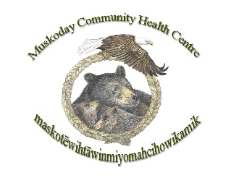
Muskoday Community Health Centre
4 Elder in Resident Program (Rotating)
2 DAYS A WEEK

Reports to
Director of Health

Operation Hours
Tuesday & Thursday
10:00 am- 3:00 pm

SALARY
$250.00 per day

POSITION Summary
The Elder in Residence will serve as a trusted cultural guide and health advocate within the Muskoday Community Health Centre. This role combines traditional knowledge with modern health practices to support wholistic well-being for community members. The Elder will provide mentorship, emotional support, and culturally grounded education while promoting harm reduction and healthy living initiatives. Responsibilities include conducting and collaborating with health staff to deliver programs that respect cultural values and address health needs such as STBBI prevention, safe injection practices, and crisis intervention. The Elder will act as a liaison between clients and resources, fostering trust, cultural competency, and positive relationships to ensure accessible, inclusive care for all.
.
Skills, Knowledge, and Abilities

- Professionalism and patient confidentiality
- Strong organizational and time management skills
- Empathy and cultural sensitivity
- Ability to work independently and collaboratively
- Problem-solving and adaptability
- Knowledge of harm reduction practices and community health

Key Responsibilities
- Supporting staff with sessions on healthy living, harm reduction, and cultural practices
- Liaise between clients and community resources (housing, social assistance, prevention services)
- Support and help train staff in cultural competency, harm reduction, and safe practices
- Help prepare and cook lunch once a week for community members (building relationships)
- Attend staff meetings, training sessions, and community events as required
- Other duties as assigned

Experience and Qualifications
- Ability to accept direction and maintain confidentiality
- Strong communication and interpersonal skills
- Knowledge of Indigenous culture, traditions, and language (preferred)
- Must provide a CPIC and Vulnerable Section Check
- Valid driver’s license and reliable vehicle

Work Conditions
- Working in the health center twice a week
- Flexible schedule for community events

Community Engagement
The Elder in Residence will actively engage with community members to strengthen relationships and promote cultural identity. This includes participating in community events, ceremonies, and gatherings, as well as facilitating dialogue on health and wellness rooted in traditional teachings. The Elder will collaborate with local organizations, schools, and cultural groups to ensure programs reflect community values and foster trust. By serving as a visible and approachable resource, the Elder will help bridge gaps between health services and cultural practices, encouraging community involvement in harm reduction and wellness initiatives.

Location
Muskoday First Nation, located 25 km southwest on Hwy #3 from Prince Albert, SK

How to Apply
Submit a cover letter, resume, and three professional references to:
Ernie Dreaver – Human Resources Officer
Email: resume@muskodayfn.ca
Deadline: April 2nd, 2026 at 4:30 pm

