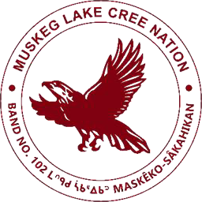

Muskeg Lake Cree Nation

Employment Opportunity 26-07

Receptionist / Administrative Assistant for Band Office
The Receptionist / Administrative Assistant will provide professional front-line and administrative support to the Muskeg Lake Cree Nation Band Office. Working under the general direction of the Office Manager, the successful candidate will ensure smooth daily operations by managing calls, correspondence, and data entry, while maintaining confidentiality and professionalism in all interactions.

Key Responsibilities
- Maintain confidentiality and adhere to the professional code of ethics at all times.
- Manage incoming and outgoing mail, phone calls, messages, and correspondence.
- Provide general administrative and clerical support to the Administration Department.
- Set up and maintain organized filing systems (electronic and physical).
- Demonstrate professionalism and courtesy as the first point of contact for visitors and callers.
- Perform other related duties as assigned by the Office Manager.
Qualifications
- Proficient in computer software applications (Microsoft Office Suite: Word, Excel, Outlook, etc.).
- Strong oral and written communication skills with excellent interpersonal abilities.
- Effective organizational and time management skills; able to work independently and as part of a team.
- Experience working within a First Nation community is an asset.
- Knowledge of Cree culture and language is an asset.
- Valid Class 5 Driver’s License required.
- Current CPIC (Criminal Record Check) must be provided by the successful candidate prior to employment.
- Professional, courteous, and reliable.
- Strong attention to detail and commitment to confidentiality.
- Positive attitude and willingness to assist team members.
- Culturally sensitive and respectful in all interactions.

Apply by sending a resume, cover letter, CPIC & VSC
to: D. Sanderson, HRM at hr@muskeglake.com
Deadline for submissions: Friday April 20, 2026 at 4:00pm

