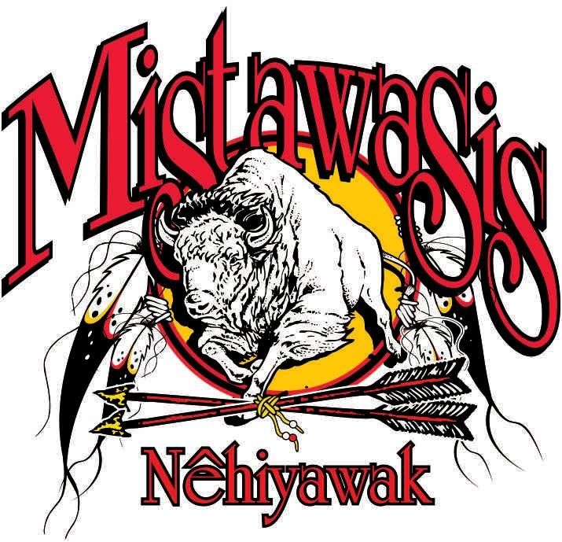 Teacher position for the 2023-2024 Academic School Year

Position: Teacher (Grade 9)

Department: Education

Location: Mistawasis Nêhiyawak High School

Apply By: Open until filled

Job Summary:
To create a class environment favourable to learning and personal growth; to establish effective rapport with students; to motivate students to develop skills, attitudes and knowledge need to provide a good foundation for upper elementary and high school education in accordance with each student’s ability; to establish good relationships with parents and other staff members

Reports to:
Principal

Job Duties:
- Have strong background in the areas of literacy and numeracy
- Ability to effectively intertwine Indigenous content into curriculum
- Strong collaboration skills to enhance academic outcomes
- Maintain accurate and complete student records, and prepare reports on children and activities, as required by Mistawasis Nêhiyawak policies, and administrative regulations
- Confer with parents, administrators, testing specialists, social workers, and professionals to develop individual educational plans designed to promote students’ educational, physical, and social needs
- Employ special educational strategies and techniques during instruction to improve the development of sensory and perceptual-motor skills, language, cognition, and memory
- Teach personal development skills such as goal setting, independence, and self-advocacy, and prepare students for later grades
- Meet with other professionals to discuss individual students’ needs and progress
- Observe and evaluate students’ performance, behaviours, social development, and physical health
- A commitment to differentiated instruction
- Have excellent classroom management skills
- Participates in curriculum development programs as required
- Perform all other acts reasonable and necessary to accomplish their primary function as requested by the Principal/Director of Education.

Education and Skills:
- Minimum education degree (B.Ed.)
- Saskatchewan Teacher’s Professional A certificate
- a current, original Canadian Criminal Record Check (CPIC) and Vulnerable Sector Check
- Ability to work collaboratively with colleagues, and with other agencies
- Ability to maintain confidentiality
- Must possess a good working knowledge of technology
- Valid First Aid/CPR/AED

Please submit cover letter, resume, and three professional references to:
hr@mistawasis.ca
Mistawasis Nêhiyawak thanks all individuals for their applications, however, only those selected for an interview will be contacted.
For further information contact:
Taylor Landry
Director of Human Resources
Mistawasis Nêhiyawak
Phone: 306-466-4800

