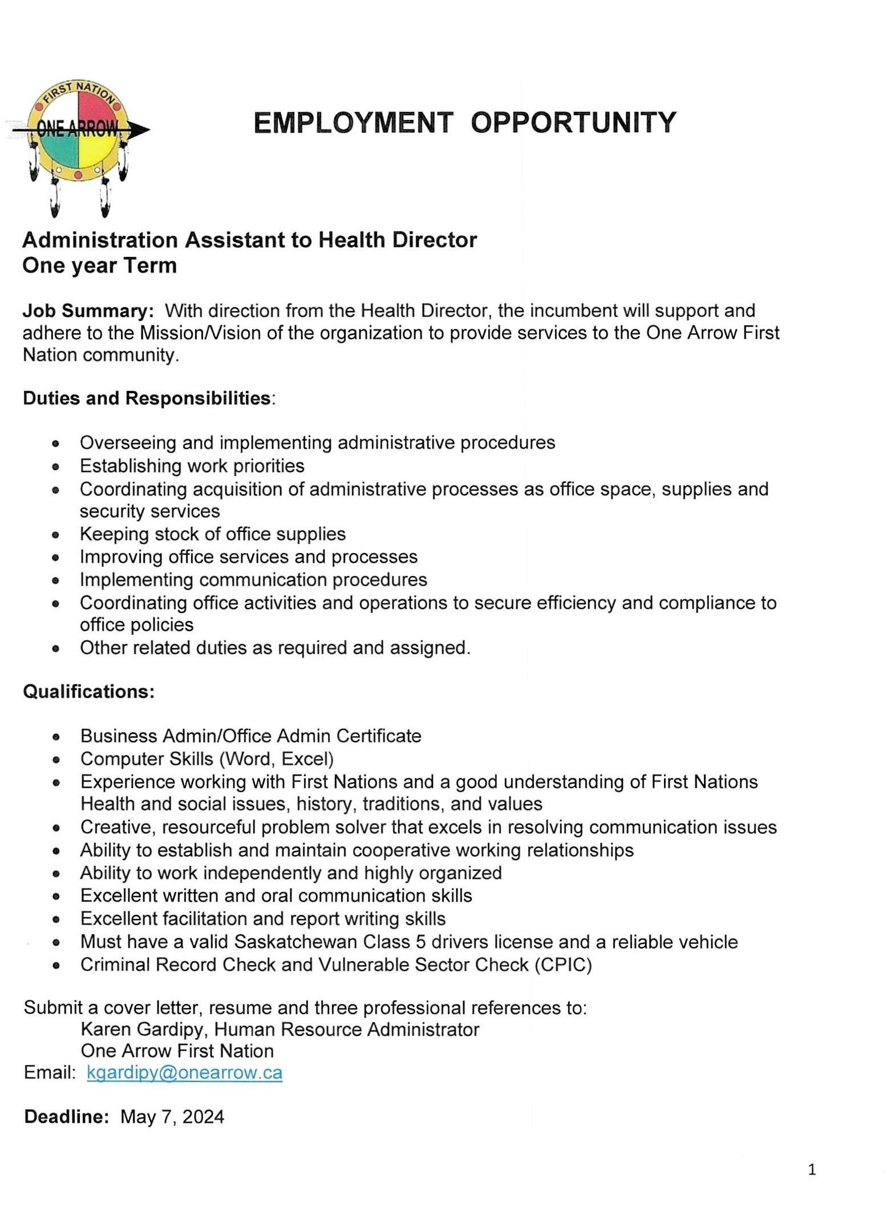
EMPLOYMENT OPPORTUNITY

o

Administration Assistant to Health Director

One year Term
Job Summary: With direction from the Health Director, the incumbent will support and adhere to the MissionNision of the organization to provide services to the One Arrow First Nation community.

Duties and Responsibilities:

Overseeing and implementing administrative procedures
Establishing work priorities
Coordinating acquisition of administrative processes as office space, supplies and
security services
Keeping stock of office supplies Improving office services and processes Implementing communication procedures
Coordinating office activities and operations to secure efficiency and compliance to
office policies
Other related duties as required and assigned.

Qualifications:

Business Admin/Office Admin Certificate
Computer Skills (Word, Excel)
Experience working with First Nations and a good understanding of First Nations
Health and social issues, history, traditions, and values
Creative, resourceful problem solver that excels in resolving communication issues
Ability to establish and maintain cooperative working relationships
Ability to work independently and highly organized Excellent written and oral communication skills Excellent facilitation and report writing skills
Must have a valid Saskatchewan Class 5 drivers license and a reliable vehicle
Criminal Record Check and Vulnerable Sector Check (CPIC)

Submit a cover letter, resume and three professional references to:
Karen Gardipy, Human Resource Administrator
One Arrow First Nation Email: kgardipy@onearrow.ca

Deadline: May 7, 2024

1

