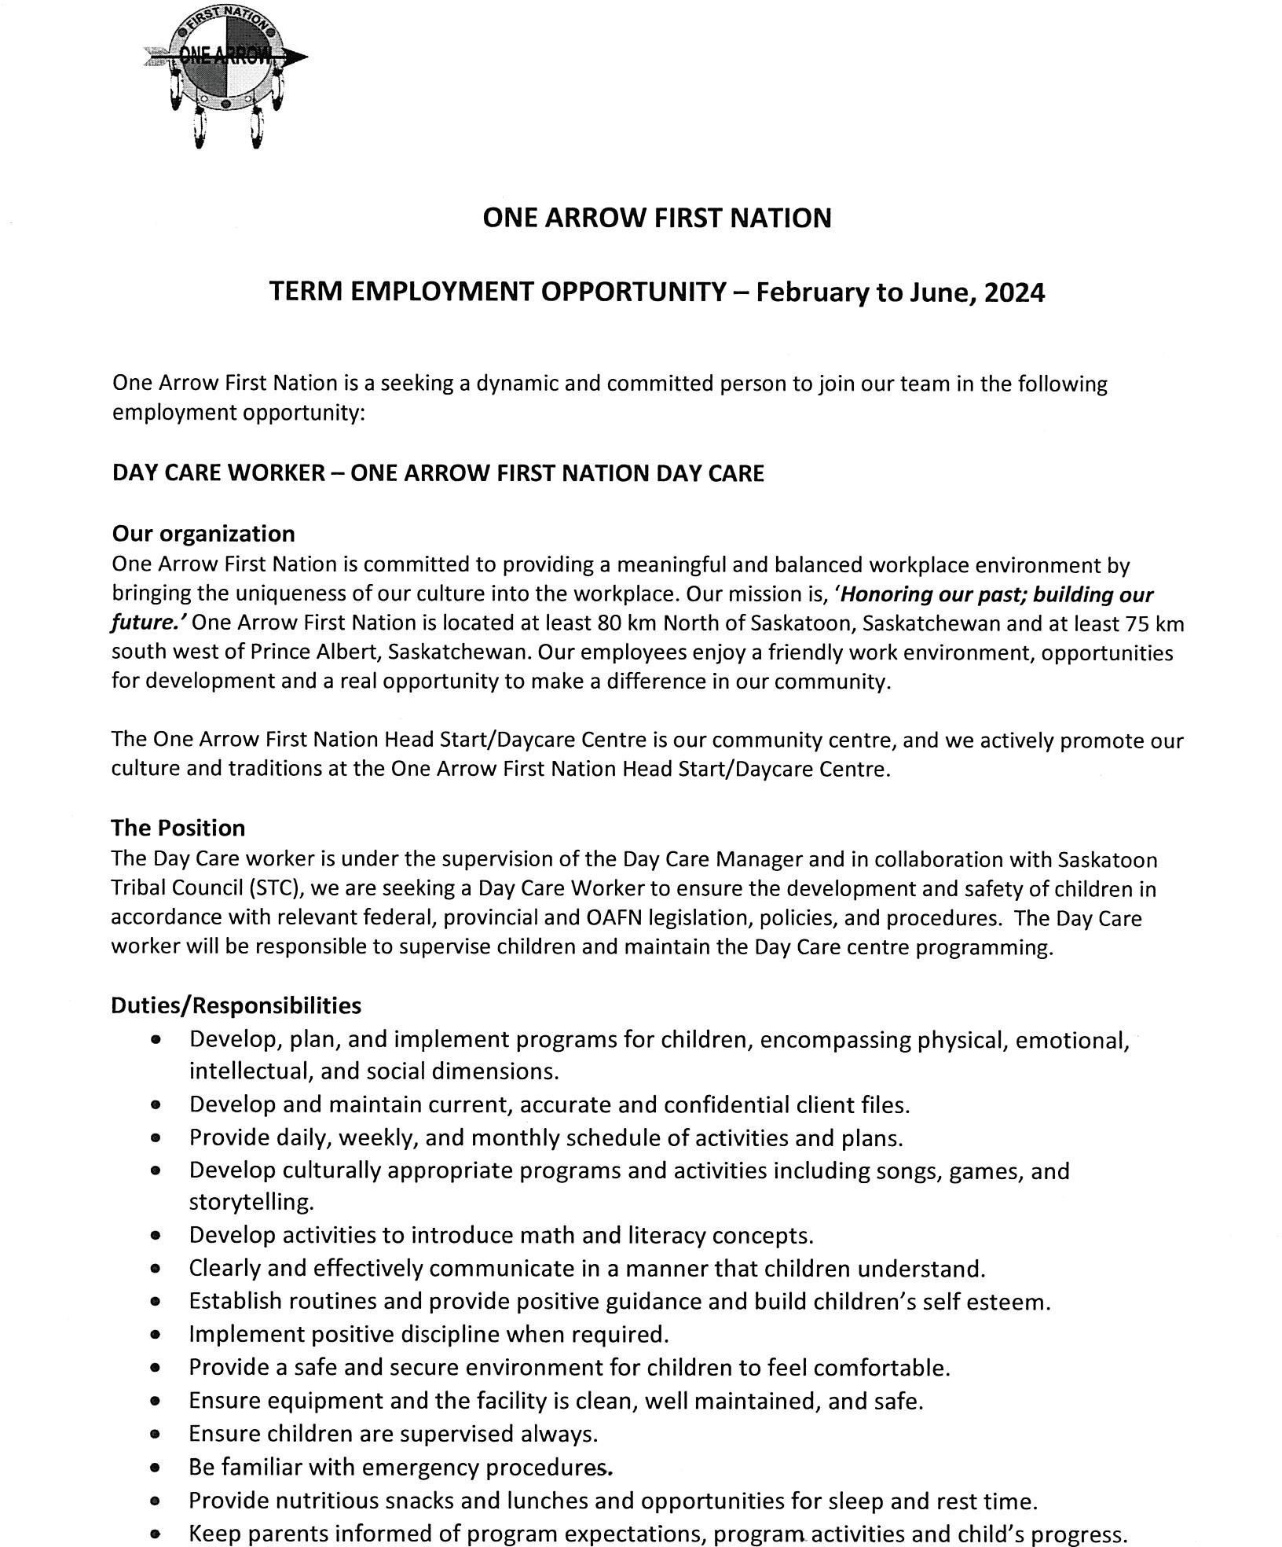

ONE ARROW FIRST NATION

TERM EMPLOYMENT OPPORTUNITY- February to June, 2024

One Arrow First Nation is a seeking a dynamic and committed person to join our team in the following employment opportunity:

DAY CARE WORKER ONE ARROW FIRST NATION DAY CARE

Our organization
One Arrow First Nation is committed to providing a meaningful and balanced workplace environment by bringing the uniqueness of our culture into the workplace. Our mission is, 'Honoring our past; building our future.' One Arrow First Nation is located at least 80 km North of Saskatoon, Saskatchewan and at least 75 km
south west of Prince Albert, Saskatchewan. Our employees enjoy a friendly work environment, opportunities for development and a real opportunity to make a difference in our community.

The One Arrow First Nation Head Start/Daycare Centre is our community centre, and we actively promote our
culture and traditions at the One Arrow First Nation Head Start/Daycare Centre.

The Position
The Day Care worker is under the supervision of the Day Care Manager and in collaboration with Saskatoon Tribal Council (STC), we are seeking a Day Care Worker to ensure the development and safety of children in accordance with relevant federal, provincial and OAFN legislation, policies, and procedures. The Day Care worker will be responsible to supervise children and maintain the Day Care centre programming.

Duties/Responsibilities
Develop, plan, and implement programs for children, encompassing physical, emotional, intellectual, and social dimensions.
Develop and maintain current, accurate and confidential client files.
Provide daily, weekly, and monthly schedule of activities and plans.
Develop culturally appropriate programs and activities including songs, games, and
storytelling.
Develop activities to introduce math and literacy concepts.
Clearly and effectively communicate in a manner that children understand. Establish routines and provide positive guidance and build children's self esteem. Implement positive discipline when required.
- Provide a safe and secure environment for children to feel comfortable. Ensure equipment and the facility is clean, well maintained, and safe. Ensure children are supervised always.
Be familiar with emergency procedures.
Provide nutritious snacks and lunches and opportunities for sleep and rest time.
Keep parents informed of program expectations, program activities and child's progress.

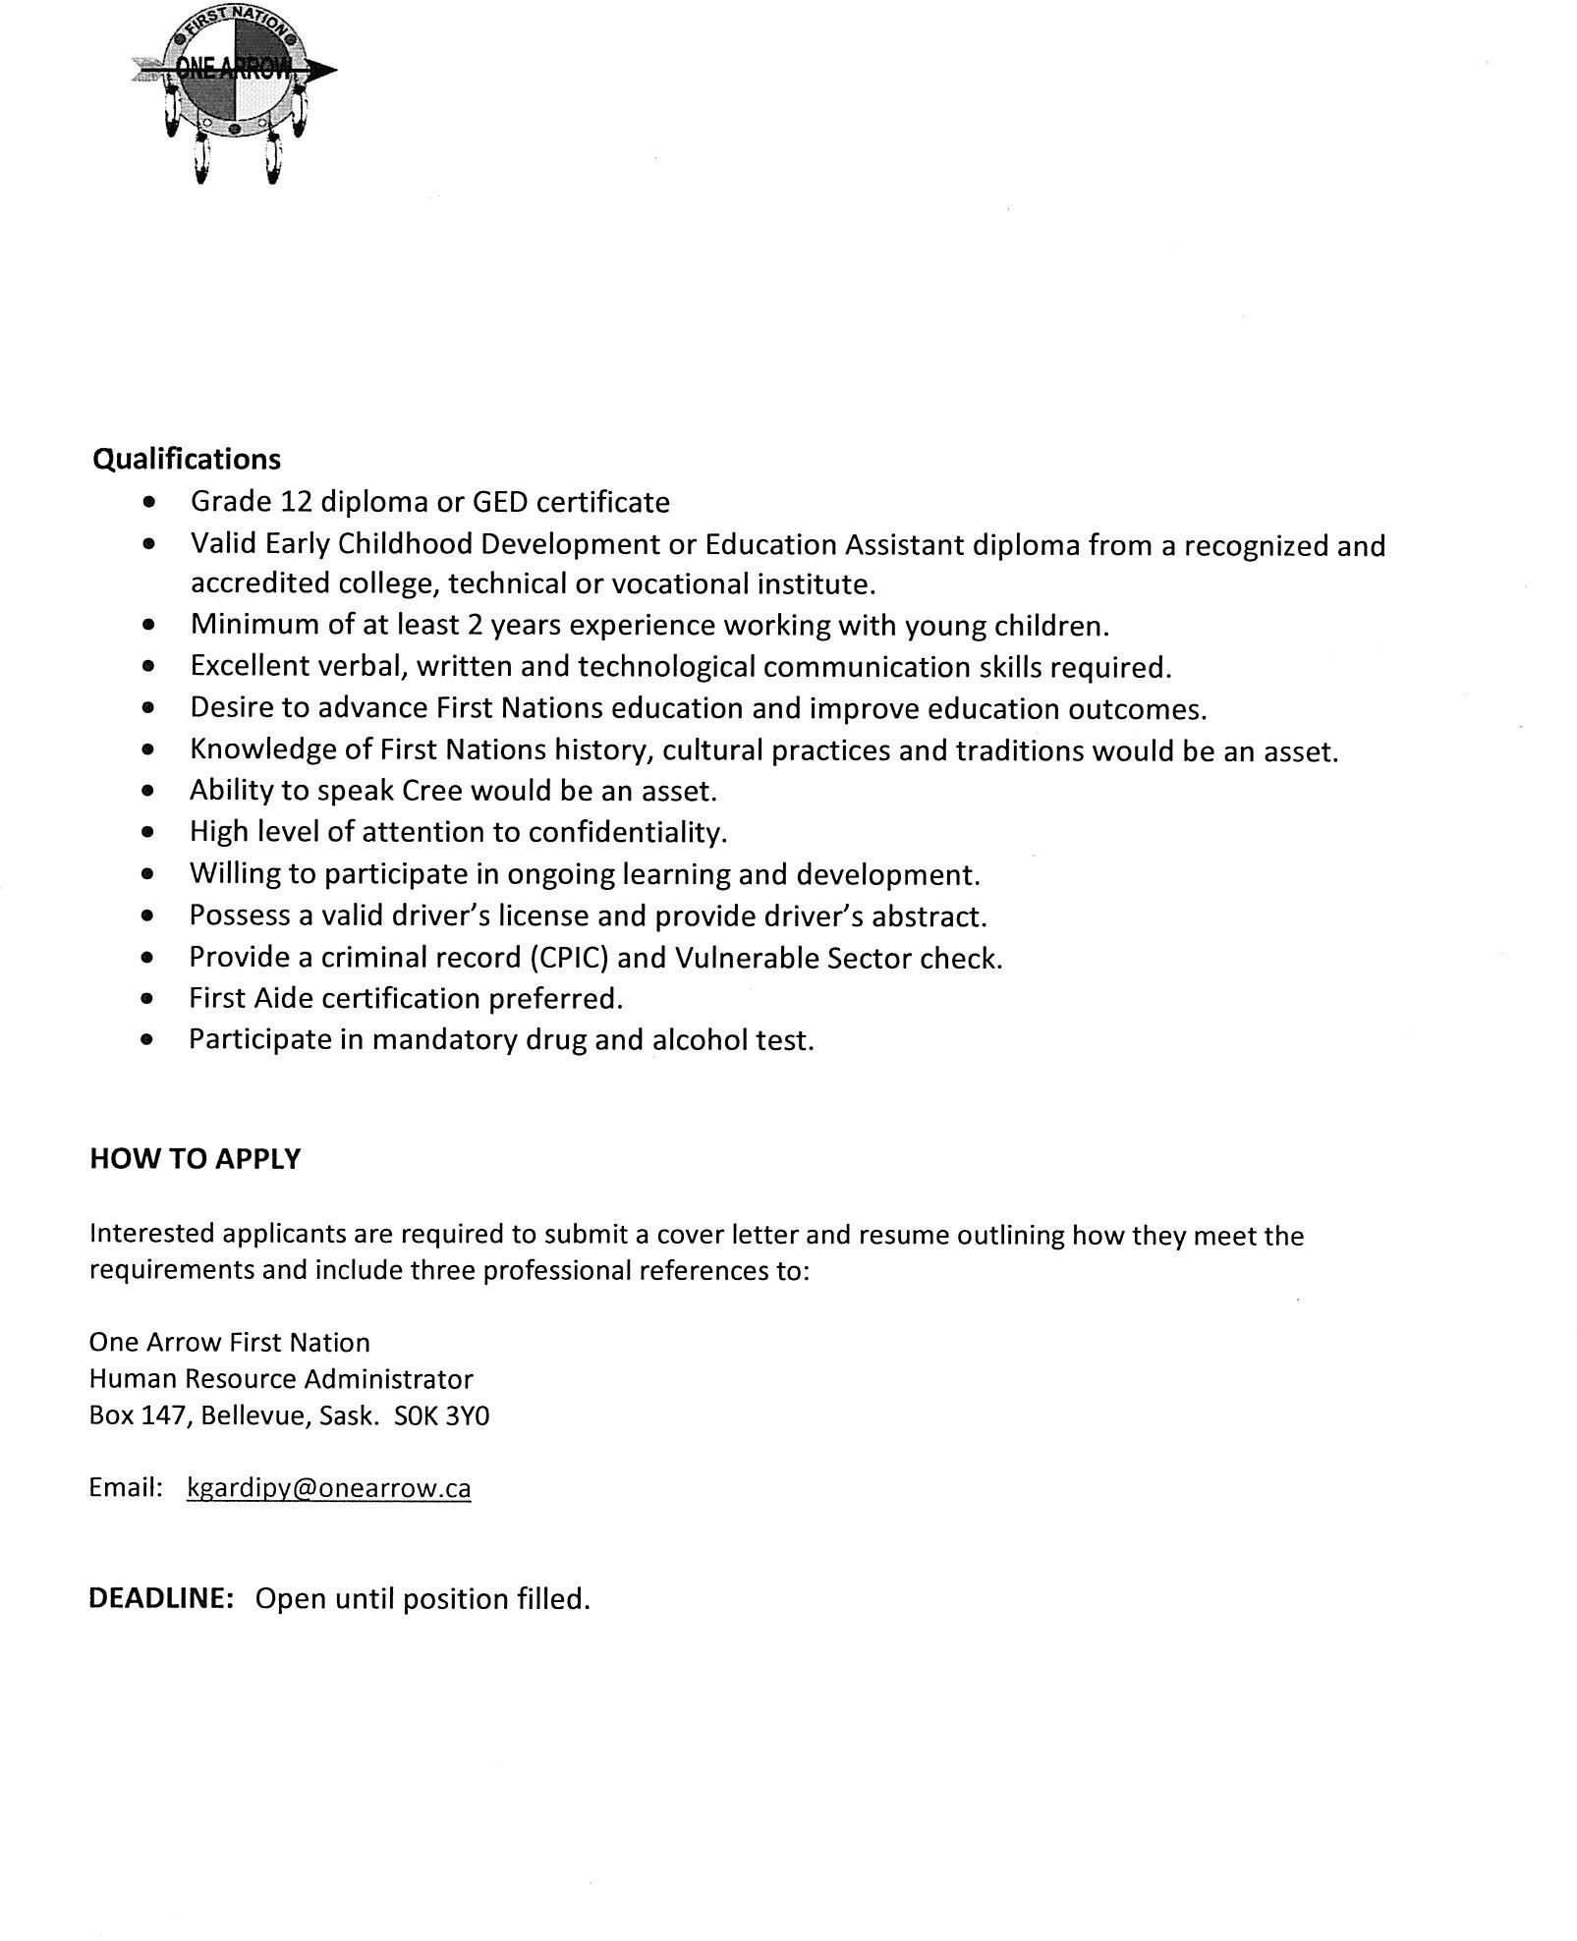
04.

Qualifications
Grade 12 diploma or GED certificate
Valid Early Childhood Development or Education Assistant diploma from a recognized and
accredited college, technical or vocational institute.
Minimum of at least 2 years experience working with young children. Excellent verbal, written and technological communication skills required. Desire to advance First Nations education and improve education outcomes.
Knowledge of First Nations history, cultural practices and traditions would be an asset. Ability to speak Cree would be an asset.
High level of attention to confidentiality.
Willing to participate in ongoing learning and development. Possess a valid driver's license and provide driver's abstract. Provide a criminal record (CPIC) and Vulnerable Sector check. First Aide certification preferred.
Participate in mandatory drug and alcohol test.

HOW TO APPLY

Interested applicants are required to submit a cover letter and resume outlining how they meet the
requirements and include three professional references to:

One Arrow First Nation
Human Resource Administrator
Box 147, Bellevue, Sask. SOK 3YO

Email: kgardipy@onearrow.ca

DEADLINE: Open until position filled.

