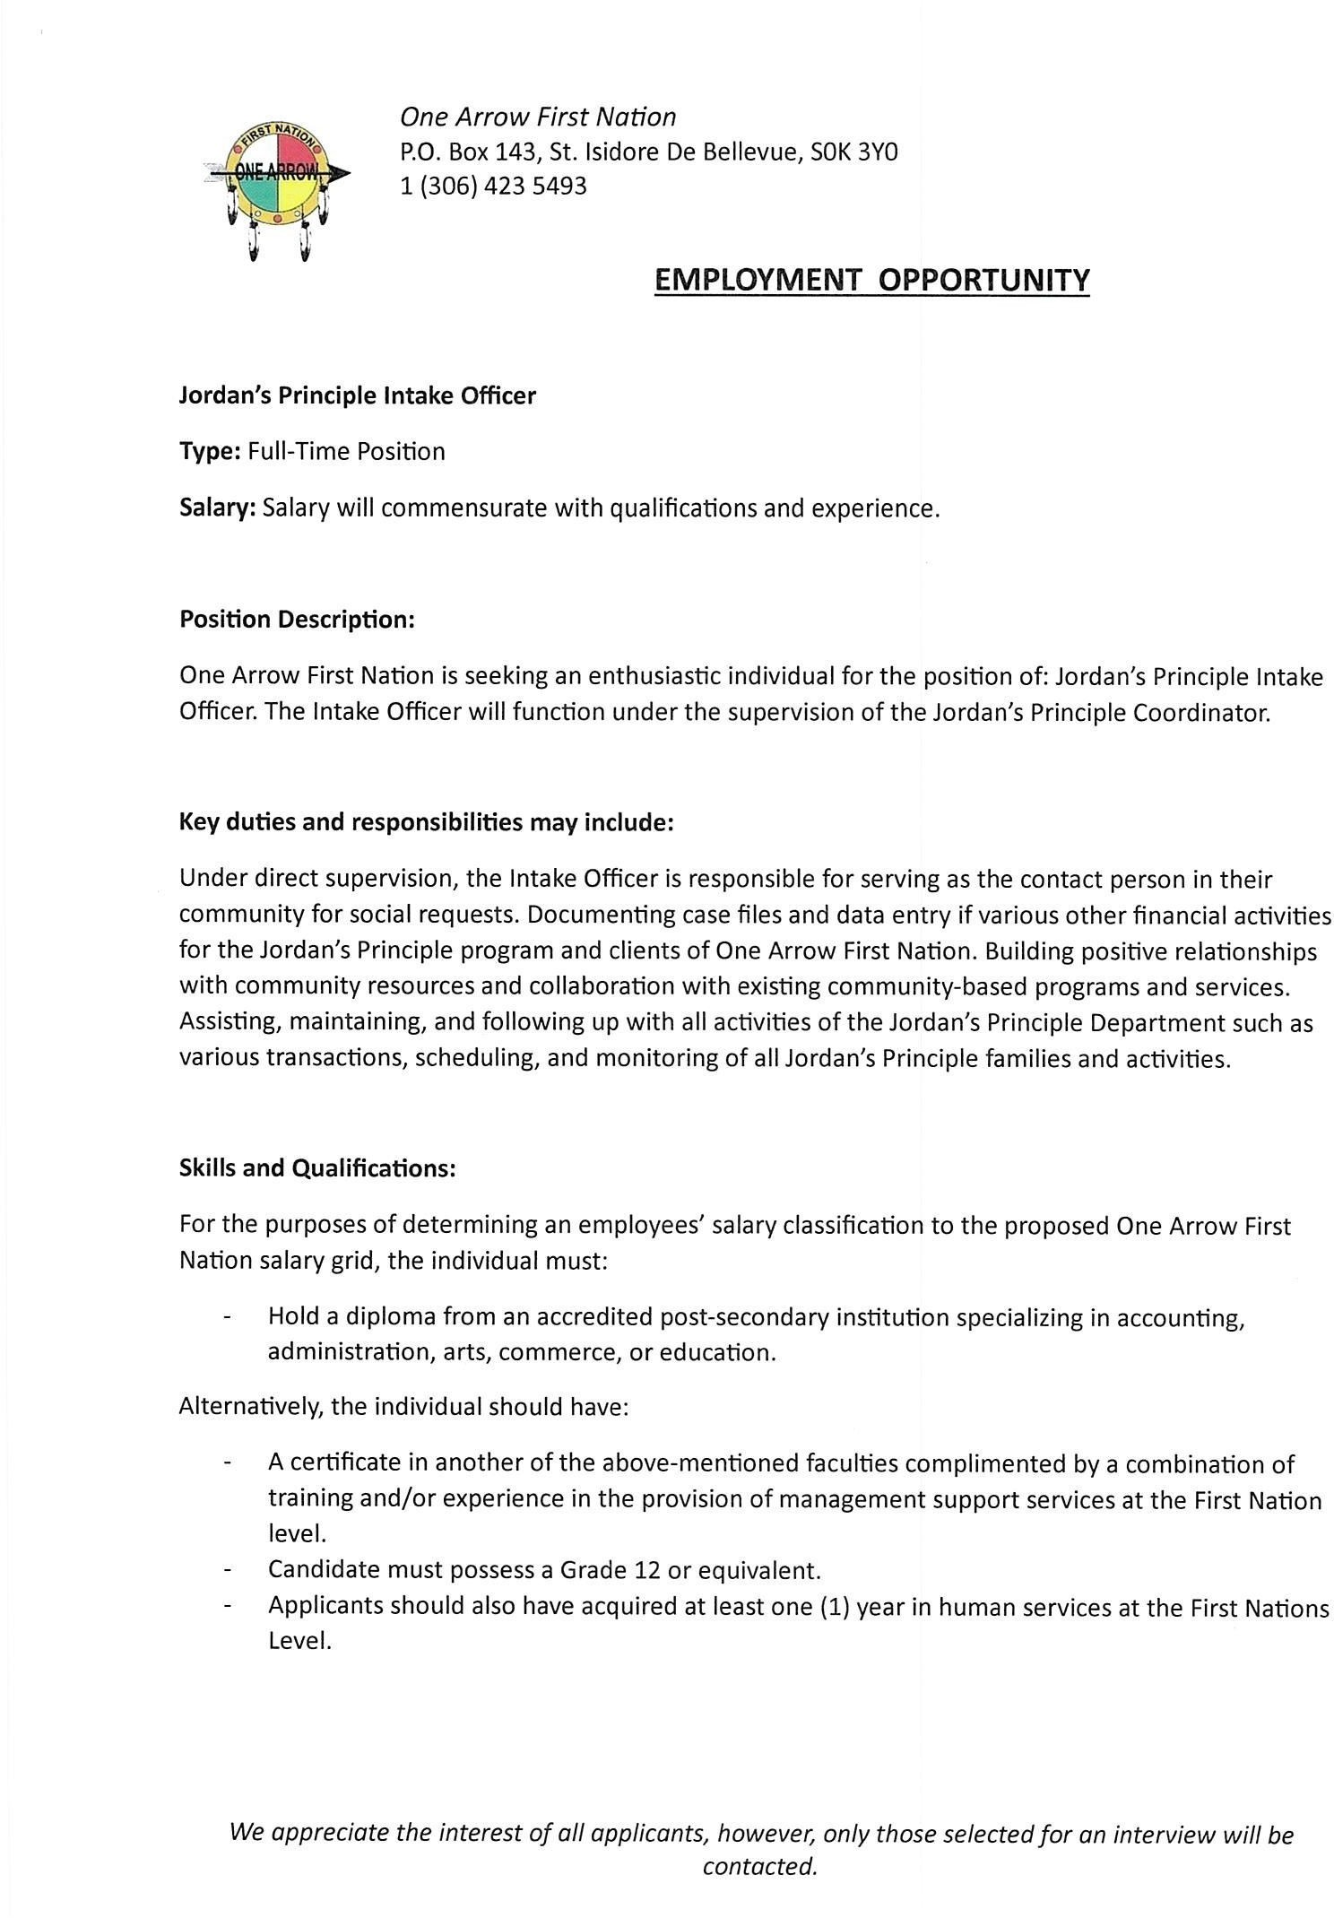
One Arrow First Nation
P.O. Box 143, St. Isidore De Bellevue, SOK 3YO
1 (306) 423 5493

EMPLOYMENT OPPORTUNITY

Jordan's Principle Intake Officer

Type: Full-Time Position

Salary: Salary will commensurate with qualifications and experience.

Position Description:

One Arrow First Nation is seeking an enthusiastic individual for the position of: Jordan's Principle Intake
Officer. The Intake Officer will function under the supervision of the Jordan's Principle Coordinator.

Key duties and responsibilities may include:
Under direct supervision, the Intake Officer is responsible for serving as the contact person in their community for social requests. Documenting case files and data entry if various other financial activities for the Jordan's Principle program and clients of One Arrow First Nation. Building positive relationships with community resources and collaboration with existing community-based programs and services.
Assisting, maintaining, and following up with all activities of the Jordan's Principle Department such as
various transactions, scheduling, and monitoring of all Jordan's Principle families and activites.

Skills and Qualifications:
For the purposes of determining an employees' salary classification to the proposed One Arrow First
Nation salary grid, the individual must:

Hold a diploma from an accredited post-secondary institution specializing in accounting,
administration, arts, commerce, or education.
Alternatively, the individual should have:
A certificate in another of the above-mentioned faculties complimented by a combination of training and/or experience in the provision of management support services at the First Nation level.
Candidate must possess a Grade 12 or equivalent.
Applicants should also have acquired at least one (1) year in human services at the First Nations
Level.

We appreciate the interest of all applicants, however, only those selected for an interview will be

contacted.

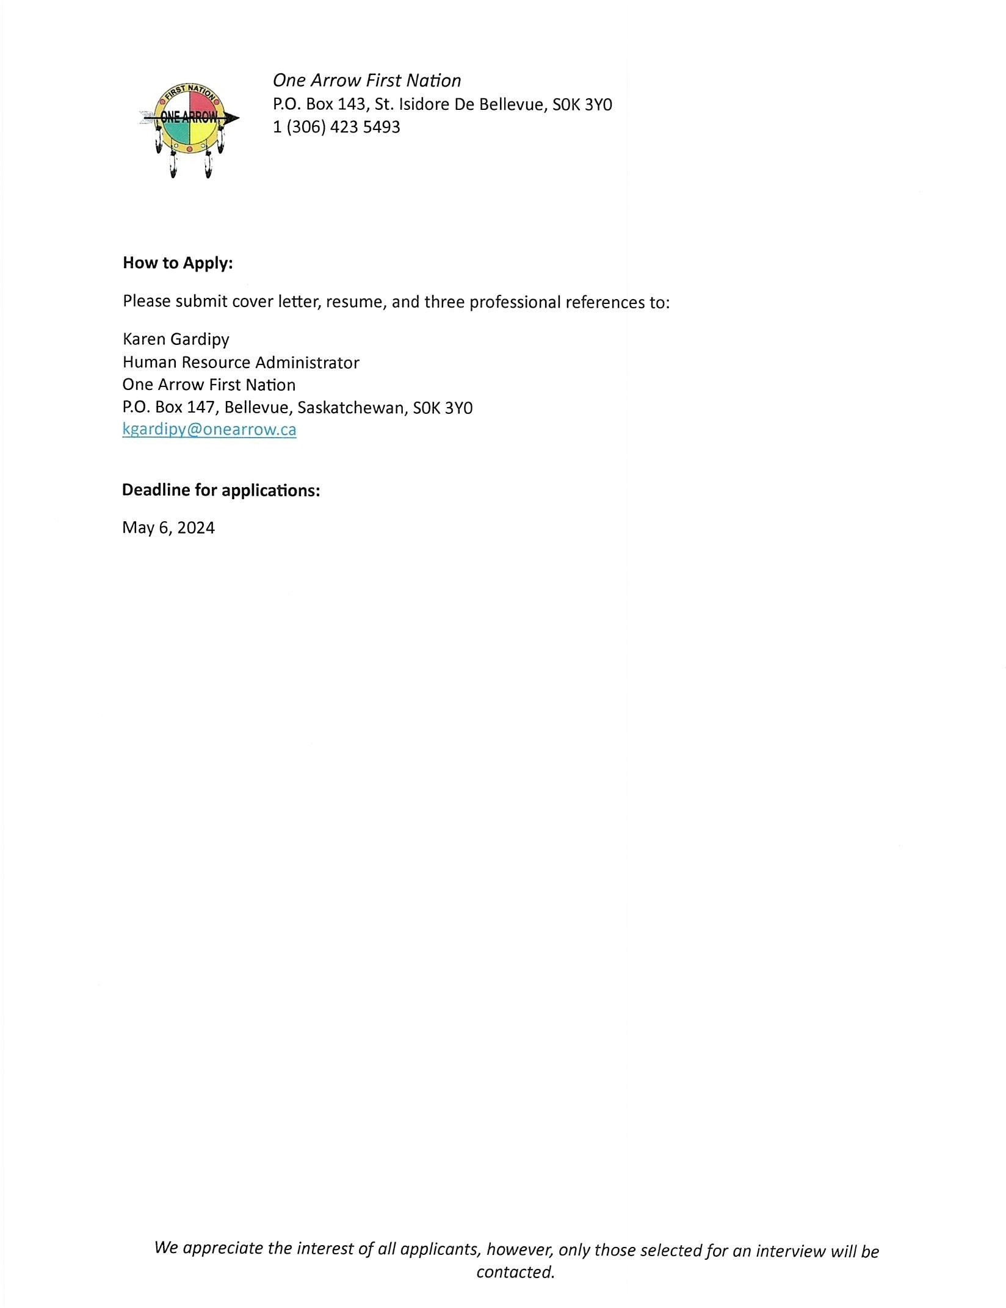
One Arrow First Nation
P.O. Box 143, St. Isidore De Bellevue, SOK 3YO
1 (306) 423 5493

How to Apply:

Please submit cover letter, resume, and three professional references to:
Karen Gardipy
Human Resource Administrator
One Arrow First Nation
P.O. Box 147, Bellevue, Saskatchewan, SOK 3Y0

kgardipy@onearrow.ca

Deadline for applications:

May 6, 2024

We appreciate the interest of all applicants, however, only those selected for an interview will be

contacted.

