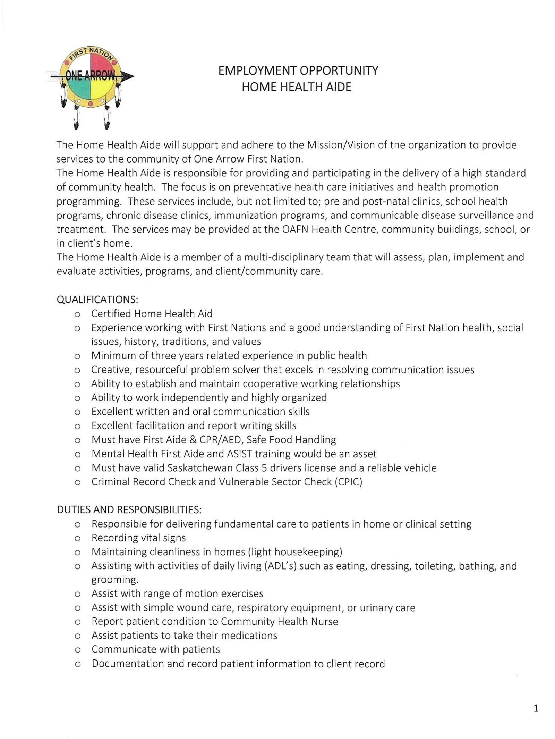
NAr,o

EMPLOYMENT OPPORTUNITY
HOME HEALTH AIDE

The Home Health Aide will support and adhere to the Mission/Vision of the organization to provide services to the community of One Arrow First Nation.
The Home Health Aide is responsible for providing and participating in the delivery of a high standard of community health. The focus is on preventative health care initiatives and health promotion programming. These services include, but not limited to; pre and post-natal clinics, school health programs, chronic disease clinics, immunization programs, and communicable disease surveillance and
treatment. The services may be provided at the OAFN Health Centre, community buildings, school, or
in client's home.
The Home Health Aide is a member of a multi-disciplinary team that will assess, plan, implement and
evaluate activities, programs, and client/community care.
QUALIFICATIONS:
- Certified Home Health Aid
- Experience working with First Nations and a good understanding of First Nation health, social
issues, history, traditions, and values
- Minimum of three years related experience in public health
- Creative, resourceful problem solver that excels in resolving communication issues
- Ability to establish and maintain cooperative working relationships
- Ability to work independently and highly organized
- Excellent written and oral communication skills
- Excellent facilitation and report writing skills
- Must have First Aide & CPR/AED, Safe Food Handling
- Mental Health First Aide and ASIST training would be an asset
- Must have valid Saskatchewan Class 5 drivers license and a reliable vehicle
- Criminal Record Check and Vulnerable Sector Check (CPIC)

DUTIES AND RESPONSIBILITIES:
- Responsible for delivering fundamental care to patients in home or clinical setting
- Recording vital signs
- Maintaining cleanliness in homes (light housekeeping)
- Assisting with activities of daily living (ADL's) such as eating, dressing, toileting, bathing, and
grooming.
- Assist with range of motion exercises
- Assist with simple wound care, respiratory equipment, or urinary care
- Report patient condition to Community Health Nurse
- Assist patients to take their medications
- Communicate with patients
- Documentation and record patient information to client record

1

HHOOWW TO AAPPPPLLYY::

SSuubbmmiitt aa ccoovveerr lleetttteerr,, rreessuummee aanndd tthhrreeee pprrooffeessssiioonnaall rreeffeerreenncceess ttoo:: KKaarreenn GGaarrddiippyy,,
HHuummaann RReessoouurrccee AAddmminiinsistrtraattoorr EEmmaaiill:: kkggaarrddiippyy@@oonneeaarrrrooww..ccaa

DDEEAADDLLIINNEE TTOO AAPPPPLLYY::
MMaayy 33,, 22002244

22

